INSTALL :

1 ) JAVA : yum install java-11-amazon-corretto.x86_64 -y

2)INSTALL DOCKER: yum install docker –y

3)JENKIN’S INSTALL ON TOMCAT WEB - THROW WAR:

-wget <https://dlcdn.apache.org/tomcat/tomcat-9/v9.0.89/bin/apache-tomcat-9.0.89.zip>

-wget <https://get.jenkins.io/war-stable/latest/jenkins.war>.

4)OPEN JENKINS DASHBOARD >> NEW ITEM >>CREATE JOB

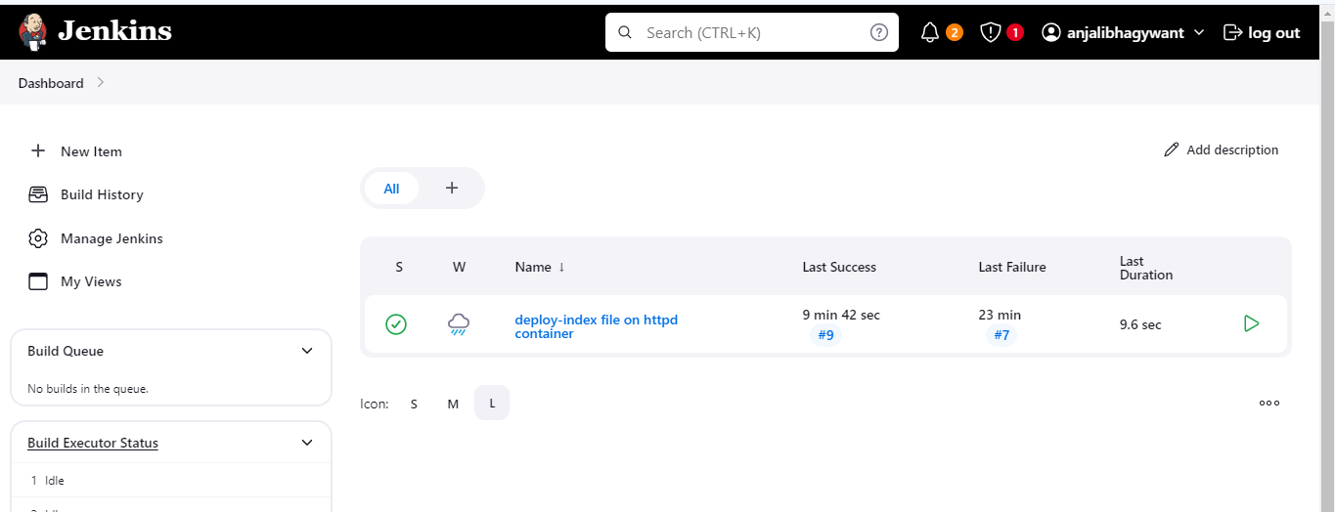

BY USING PIPELINE SCRIPTES AS FALLOWS:

pipeline {

agent any

stages {

stage('Clean Workspace') {

steps {

deleteDir()

}

}

stage('Git Clone 2024-Q1-BRANCH') {

steps {

git branch: '2024-Q1', url: 'https://github.com/bhagywantanjali/june-2024.git'

}

}

stage('Setup HTTPD ON PORT-80 2024-Q1') {

steps {

sh 'docker rm -f my-server-Q1'

sh 'docker run -dp 80:80 --name my-server-Q1 httpd'

sh 'chmod -R 777 index.html'

sh 'docker cp index.html my-server-Q1:/usr/local/apache2/htdocs/'

}

}

stage('Git Clone 2024-Q2-BRANCH') {

steps {

git branch: '2024-Q2', url: 'https://github.com/bhagywantanjali/june-2024.git'

}

}

stage('Setup HTTPD ON-90 2024-Q2') {

steps {

sh 'docker rm -f my-server-Q2'

sh 'docker run -dp 90:80 --name my-server-Q2 httpd'

sh 'chmod -R 777 index.html'

sh 'docker cp index.html my-server-Q2:/usr/local/apache2/htdocs/'

}

}

stage('Git Clone 2024-Q3-BRANCH') {

steps {

git branch: '2024-Q3', url: 'https://github.com/bhagywantanjali/june-2024.git'

}

}

stage('Setup HTTPD-ON-8081 2024-Q3') {

steps {

sh 'docker rm -f my-server-Q3'

sh 'docker run -dp 8081:80 --name my-server-Q3 httpd'

sh 'chmod -R 777 index.html'

sh 'docker cp index.html my-server-Q3:/usr/local/apache2/htdocs/'

}

}

}

}

-------------------------------------------------------------------------------------------------------------------------------------------------------------------

CONFIGER SECURITY GROUP IN EC2 :

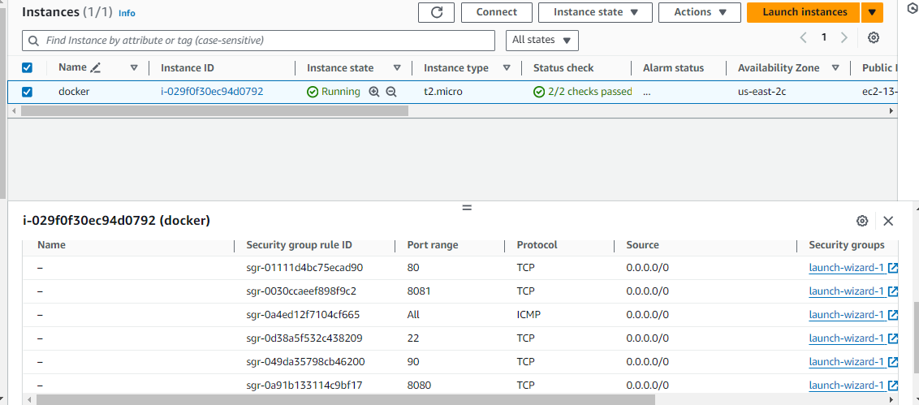

OUTPUT:

1)HTTPD CONTAINER-Q1 CONFIGURE ON PORT NO 80:80

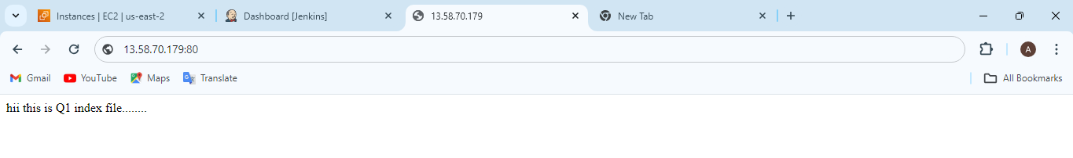

1)HTTPD CONTAINER-Q2 CONFIGURE ON PORT NO 90:80

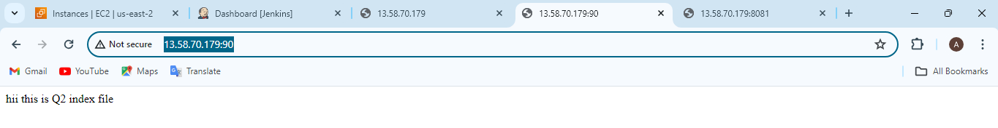

1)HTTPD CONTAINER-Q3 CONFIGURE ON PORT NO 8081:80

